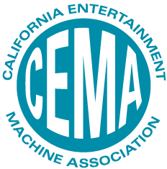
FOR IMMEDIATE RELEASE 7/23/24

The California Entertainment Machine Association (CEMA) has announced the date for the 2025 Annual Spotlight Show. The much anticipated show will be held Friday, January 31st, 2025 at The Captain’s Auction Warehouse and Showroom in Anaheim.
This premier event is designed to bring together industry professionals for a day of networking, education, access to state legislators and exploration of the latest products and services.
CEMA President Jim Wyatt stated “We are excited to announce the date of our 2025 show. We feel it is one of the most unique and engaging shows in our industry, not only showcasing the latest from top vendors but also providing attendees a chance to engage with policy makers and state legislators that regularly attend our show.”
CEMA Annual Spotlight Show
Friday, January 31st, 2025
Captains Auction Warehouse and Showroom
4421 E La Palma Ave.
Anaheim, CA 92807
Morning education sessions and CEMA meetings 8am-noon.
Show floor open at noon, open until 4pm
Catered lunch is included.

