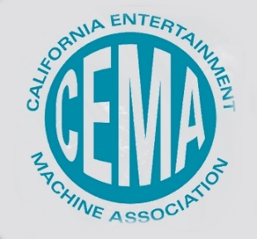

Dear Dr. Doohan,
The California Entertainment Machine Association (CEMA) represents nearly 100 locally owned small businesses as well as manufacturers and suppliers of equipment used for the amusement vending industry and impacts nearly 750 companies and thousands of Californians. Our machines are operated in well over 10,000 restaurants, bars and retail establishments throughout the state. Most of our machines are operated by individuals and social distancing is not an issue. Our machines are also located in movie theaters, bowling alleys and other Family Entertainment Centers. Like these industries, our industry has been devastated by the Covid-19 shutdowns.
CEMA members appreciate the efforts of lawmakers and the difficult decisions they have been forced to make to ensure our safety through the Covid-19 crisis. We understand that these measures were adopted to protect the public and the California economy.
CEMA members take seriously our obligations to the safety of the public. To that end, CEMA has compiled best practices to meet the challenge of operating during and after the Covid-19 pandemic which incorporate recommendations from the CDC. CEMA member businesses have robust plans for reopening our operations while adhering to all appropriate safety measures. We are committed to the health and safety of our employees and all customers.
It should also be noted that on May 22, the CDC reiterated:
The primary and most important mode of transmission for COVID-19 is through close contact from person-to-person. Based on data from lab studies on COVID-19 and what we know about similar respiratory diseases, it may be possible that a person can get COVID-19 by touching a surface or object that has the virus on it and then touching their own mouth, nose, or possibly their eyes, but this isn’t thought to be the main way the virus spreads.
CEMA member businesses are critical to the economy of California. Our revenues support many local industries such as mechanics, parts suppliers, cleaning product suppliers, retailers and wholesalers, and the travel industry. Commissions paid support many local and regional restaurants, bars and retail establishments. Income from our machines funds city, county and state tax coffers.
The current epidemic has stretched many of our California small business owners to the breaking point. If unable to resume operations soon, many will be forced to permanently close. This will result in tax revenue drops, unemployment, more uninsured residents, abandoned equipment, fire sale scenarios, and for many small operators - bankruptcy.
Please consider our industry in reopening plans and ensure that our machine placements remain vibrant contributors to the California economy. Leaders from CEMA would be happy to meet with you at any point to discuss our businesses and actions we are taking to ensure safety.
Sincerely,
Jim Wyatt President CEMA, National Entertainment Network AM
Ron Hunt Betson Enterprises
Michael Martinez N2 Industries
Nick Montano Andamiro USA
Rachel Rosenberg A & A Global
Chris Campbell Captain’s Auction
Lawrence Coelho West Coast Amusement
Rick Landis Primetime Amusement
Heidi Olsen-Hughey HOH Consulting
Evan Steiner Enteractive Networks
Jason Scherer Pelican Group
John English Automated Entertainment

